PRODUCT RECALL/DISABLEMENT DRILL REPORT

Function: | Prepared by: | Reviewed by: | Approved by:
Department: | Quality Assurance | Systems and cybersecurity | Quality Assurance
Name: | Ivan Perez | David Pozo | Fernando Pozo
Signature:
Date:

Content
1. Objective 3
2. Simulated scenario 3
3. Actions taken 3
4. Results 6

- Aim
Verify the effectiveness of the product recall procedure (PNT-008), including the technical mechanisms for disabling and communicating with internal users.

- Simulated scenario
Reason for withdrawal: A critical flaw has been detected that compromises unauthorized access to user data.
Risk assessment: High.
Affected version: 1.0.0
Date of the drill: 10/07/2025

- Actions taken
- Identification of the affected version, responsible for the action: IT
  - The version with the bug has been located in the database.
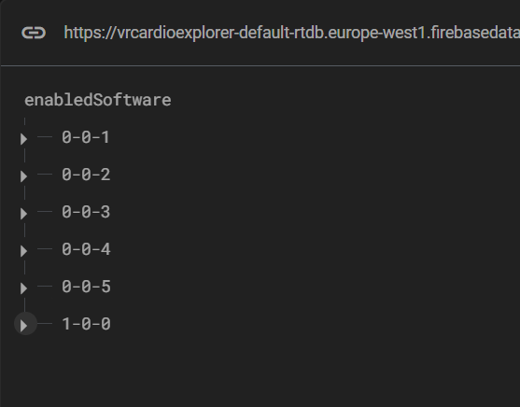
- Technical disqualification, responsible for the action: IT
  - The access parameter has been modified to prevent its use.
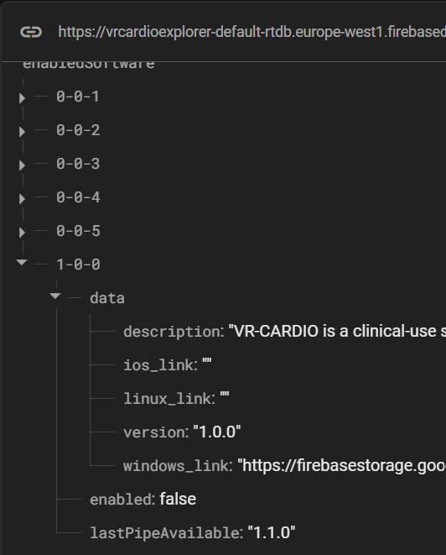

- Blocking verification, responsible for the action: IT
  - An access attempt test has been performed
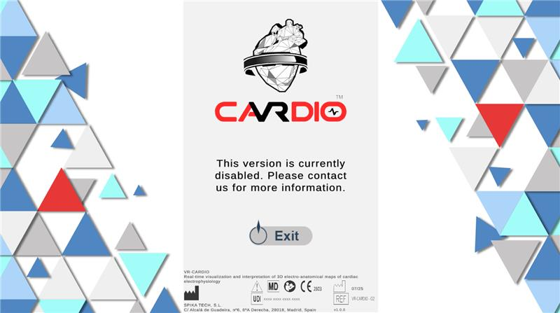

- Internal Communication, responsible for the action: Quality
  - The departments involved are informed
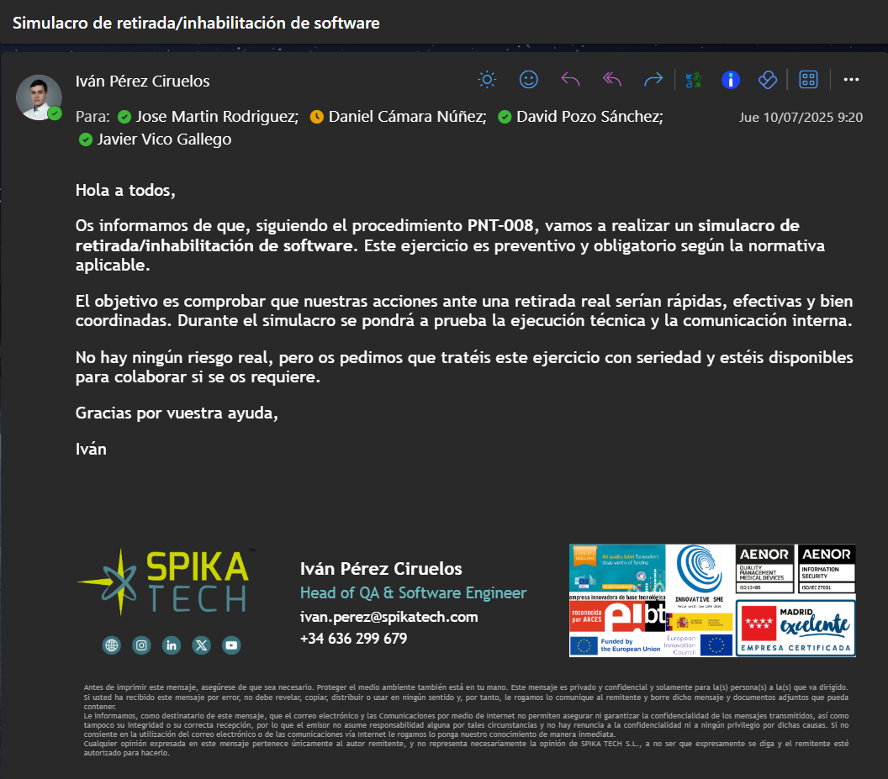

- Results
Was access to the affected version successfully blocked? Yes
Were the affected departments notified? Yes
Conclusion on the effectiveness of the procedure: The simulation was carried out satisfactorily, meeting the planned timeframe and demonstrating that the PNT-008 procedure is effective for managing software withdrawals or disabling. The affected version was correctly identified and remotely disabled, preventing access by simulated users. Internal communication worked adequately, and the departments involved responded as expected.

